Rakshith Churchagundi Amarnath

A20424771

Assignment 5

1. Magic Number = 158096

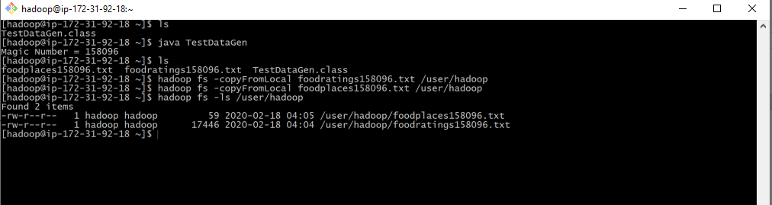

food_ratings = load 'foodratings158096.txt' USING PigStorage(',') as (name:chararray, f1:int, f2:int, f3:int, f4:int, placeid:int);

DESCRIBE food_ratings;

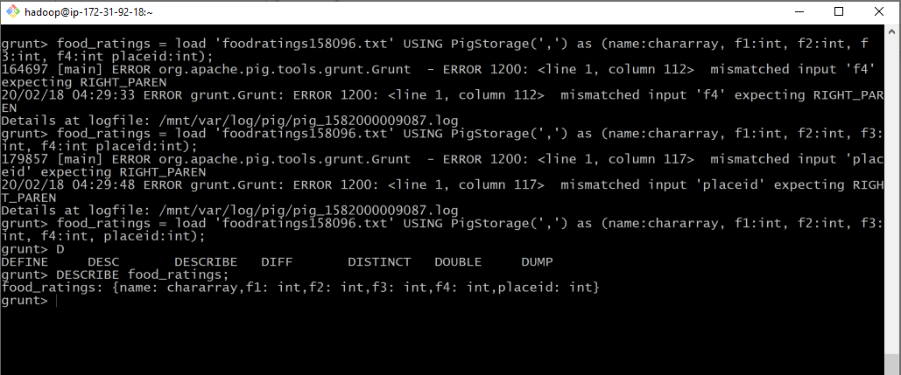

2)

grunt> food_ratings_subset = FOREACH food_ratings GENERATE name, f4;

grunt> store food_ratings_subset into 'food_ratings_subset';

X = LIMIT food_ratings_subset 6;

DUMP x;







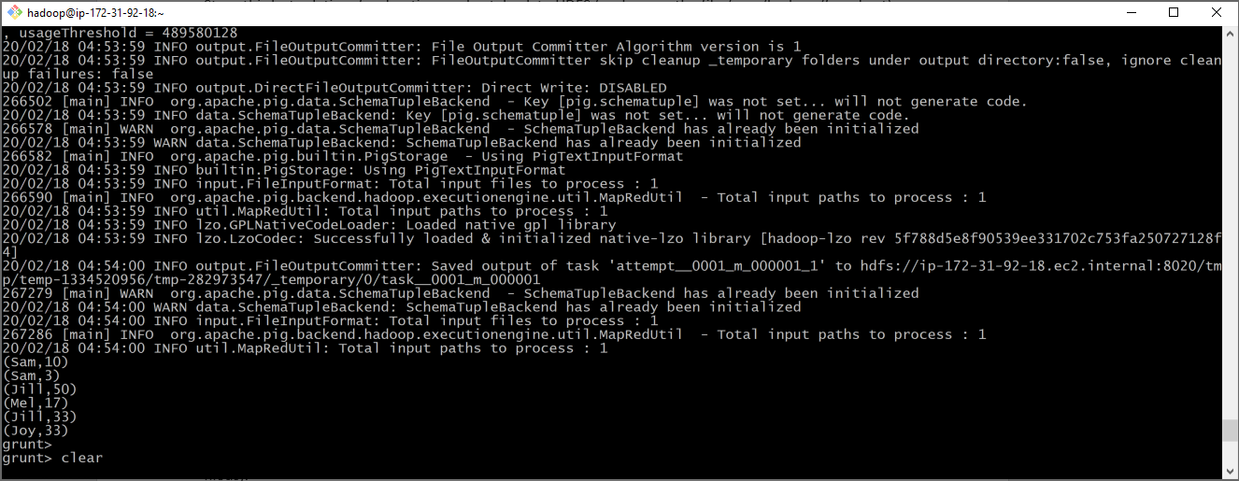

3)

grouped = GROUP food_ratings ALL;

food_ratings_profile = FOREACH grouped GENERATE MIN(food_ratings.f2), MAX(food_ratings.f2), AVG(food_ratings.f2), MIN(food_ratings.f3), MAX(food_ratings.f3), AVG(food_ratings.f3);

DUMP food_ratings_profile

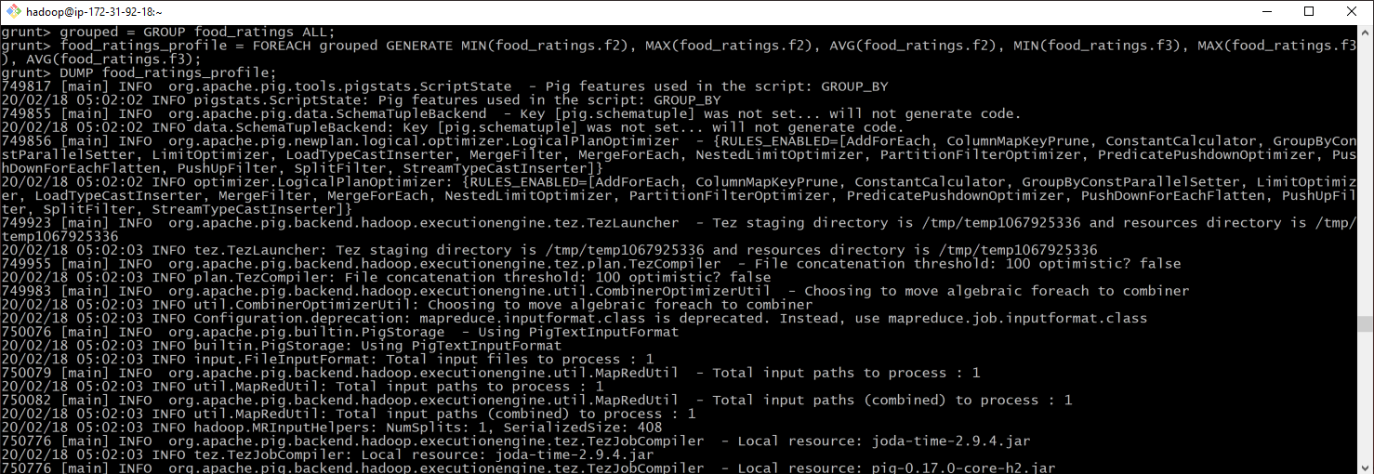

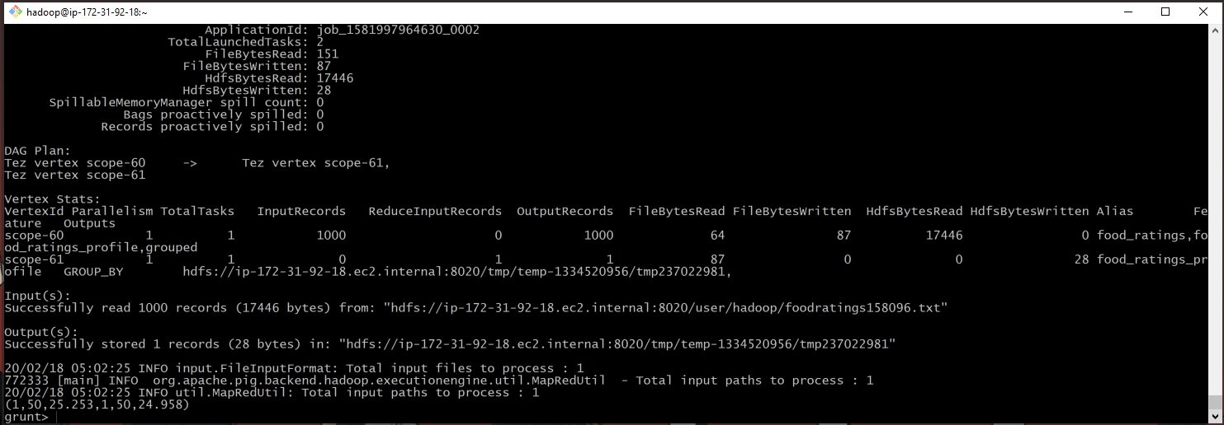

4)

food_ratings_filtered = FILTER food_ratings BY f1 < 20 and f3 > 5;

X = LIMIT food_ratings_filtered 6;

DUMP X;

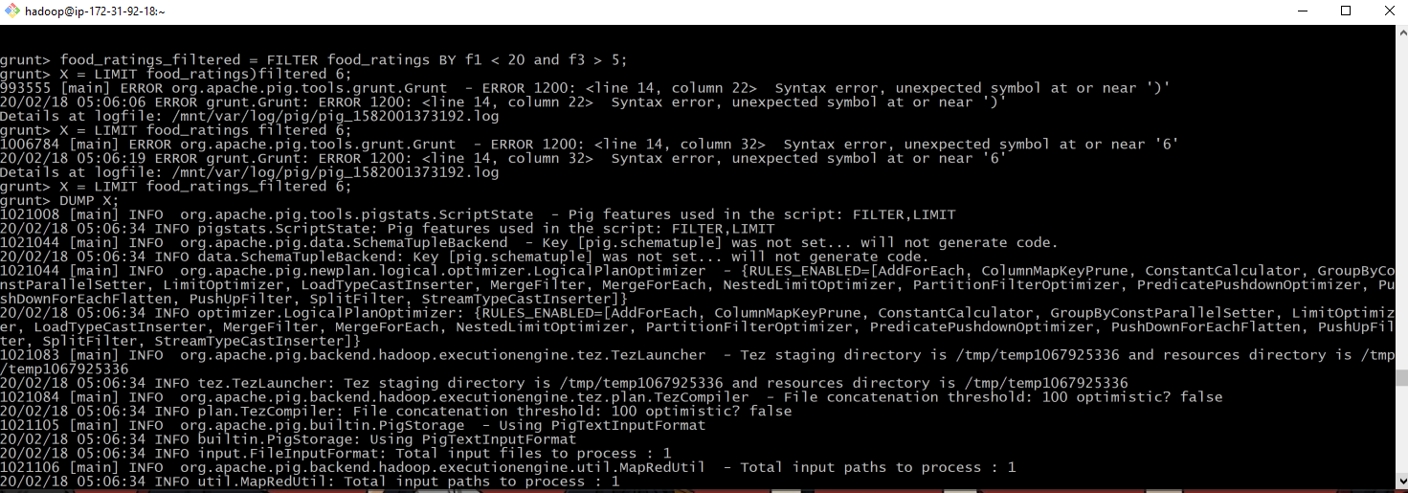

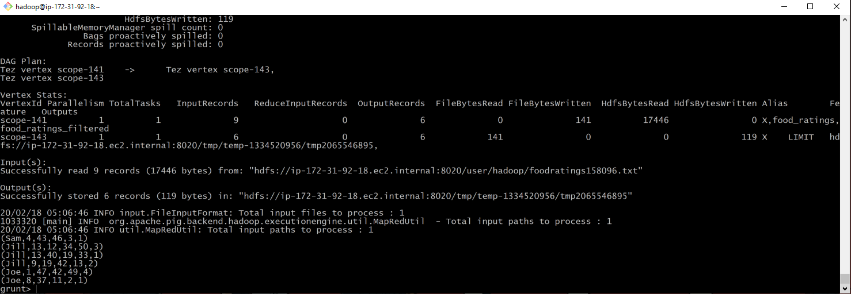

5.

food_ratings_2percent = SAMPLE food_ratings 0.02;

X = LIMIT food_ratings_2percent 10;

DUMP X;

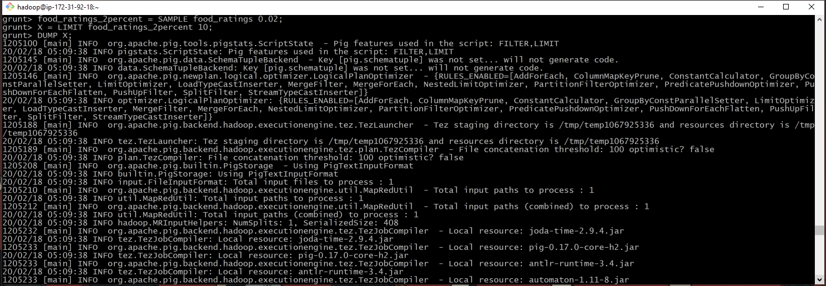

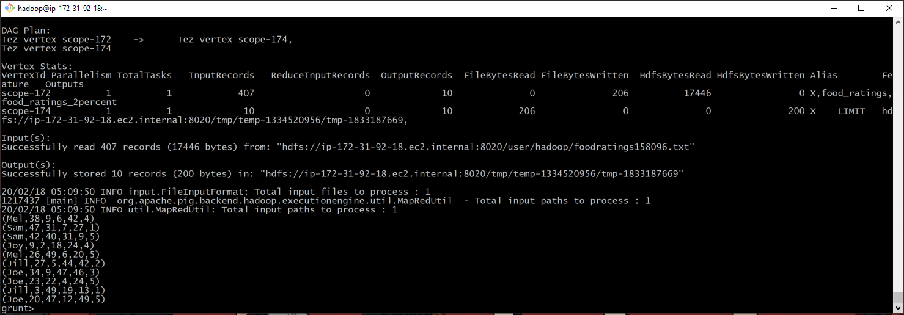

6)

food_places = load 'foodplaces158096.txt' USING PigStorage('.') as (placeid: int, placename:chararray);

DESCRIBE food_places;

food_ratings_w_place_names = JOIN food_ratings BY placeid, food_places BY placeid;

V = LIMIT food_ratings_w_place_names 6;

DUMP V;

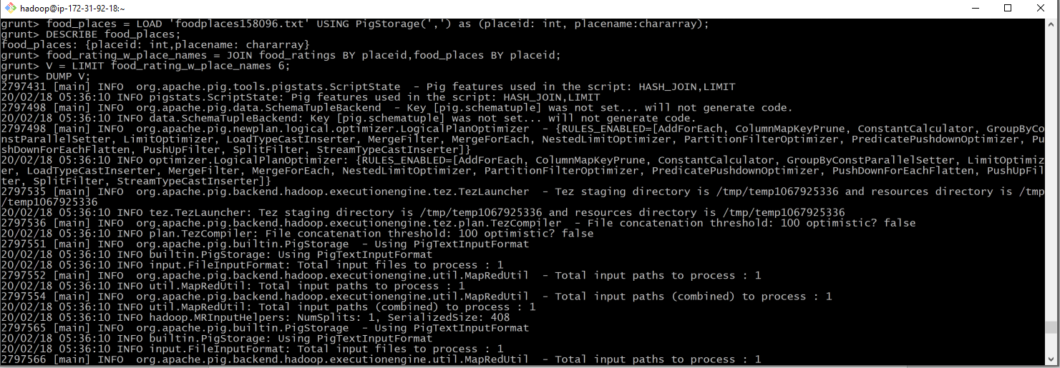

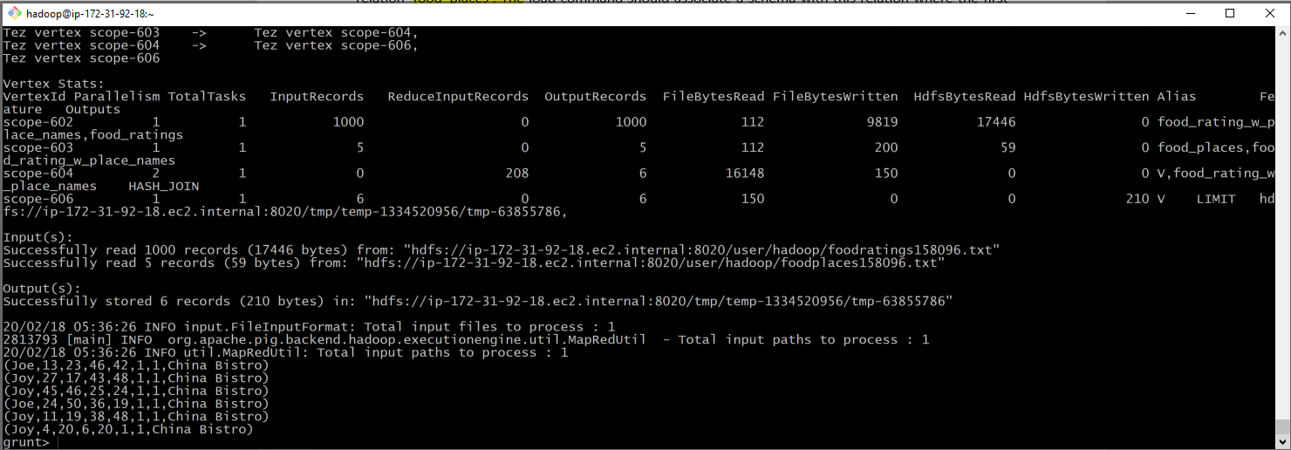

7)

I. (A) LIMIT

II. (C) DISTINCT

III. (B) (f1: STRING, f2: INT, f3: INT, f4: INT)

IV. (B) relB = FOREACH relA GENERATE $0, f3;

V. (B) data flow

VI. : (A) relB = FILTER relA by $0 < 20